Molecular dynamics simulation of Argon liquid

July 5, 2018

1. Problem description

Consider a cubic grid of 10 x 10 x 10, each cell is loaded with an Argon atom. We are going to see how the Argon atoms interact with each other using molecular dynamics simulations. You are asked to start from scratch and pick a programming language of your interest(s) and demonstrate the how the system behaves in the liquid phase (temperature: 119.8 K).

1. Background information
   1. Potential energy

Argon atoms are neutral. We only consider the pairwise interaction between the atoms. The potential energy between a pair of atoms *i* and *j* is described by Lennard-Jones potential

$v\left(r_{i}, r_{i}\right)=4ϵ\left[{\left(\frac{σ}{r}\right)}^{12}-{\left(\frac{σ}{r}\right)}^{6}\right]$

where $r_{i}$ or $r_{j}$ is the position vector of atom *i* or *j* and r is the distance between the two atoms. $σ$ is the equilibrium distance between the two atoms, as shown in the following figure. As you can see, the interaction is very short-ranged. If you cut the interaction range to rcut = 2 you can still keep 97% of the potential energy. If you cut the interaction range to rcut = 4 you can still keep 99.95% of the potential energy. Therefore, in your simulation, you don’t need to consider the interaction between each pair, instead, for a specific atom, you can set a cutoff (I suggest a cutoff of half the box size for simplicity) to only consider the interaction between atoms within the cutoff distance.



Figure 1 Lennard Jones potential

* 1. Periodic boundary conditions

To mimick the condition of infinite number of Argon atoms, we will need to use the periodic boundary conditions. Since most of the atoms are on the surface in a system of 10 x 10 x 10, surrounding the surface with replicas of itself would take care of the limited size effect. Since the pairwise interaction is shortranged, we can limit the interaction between atom i to only atom j or one of the its replicas j’, whoever is closer to atom i (distance within cutoff).

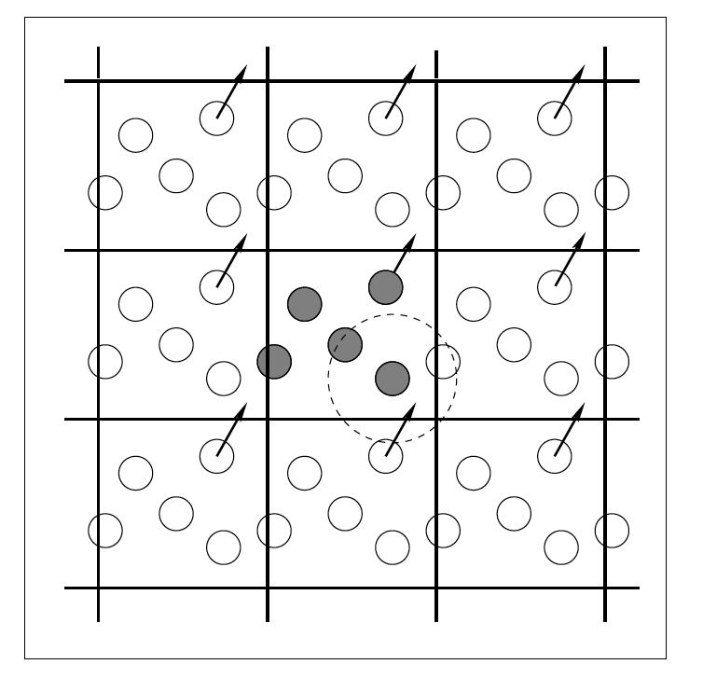

Figure 2Periodic boundary conditions. The gray circles are the original system and the white circles are the replicas. The dotted-line circle shows the interactions for the atom in the middle of the circle.

* 1. Derive the equation of motion  
     The force f between each atom is derived from the potential energy. Equation of motion is then derived from Newton’s second law. For atom i,  
     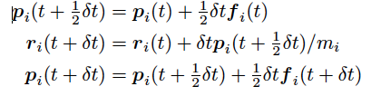
  2. Output and visualization

Your output should be the coordinates, velocities, temperature and the total energy. Hint: how to compute the temperature using its microscopic definition. There are quite a few tools to visualize the system over time. I recommend VMD or ParaView.

Extra Materials:

Here are a couple of videos of simulation of the argon system:

<https://www.youtube.com/watch?v=MELwXjUrejg>

<https://www.youtube.com/watch?v=NJhzfkTAdmI>

<https://www.youtube.com/watch?v=voTJ9Mrg3Xs>

The third video can help you understand how the periodic boundary conditions work.

<https://ebookcentral.proquest.com/lib/uh/reader.action?docID=307221&ppg=24>